**DEPARTMENT OF INFORMATION TECHNOLOGY**

**Course Name and Code:** Data Structures Lab **(**ITL302)

**Semester:** III (SYIT)

**Academic Year:** 2024-25 (Odd Semester)

**Experiment No. 05**

**Aim:** **Implementation of Singly Linked List / Circular Singly Linked List and various operations for real-world.**

**Code:**

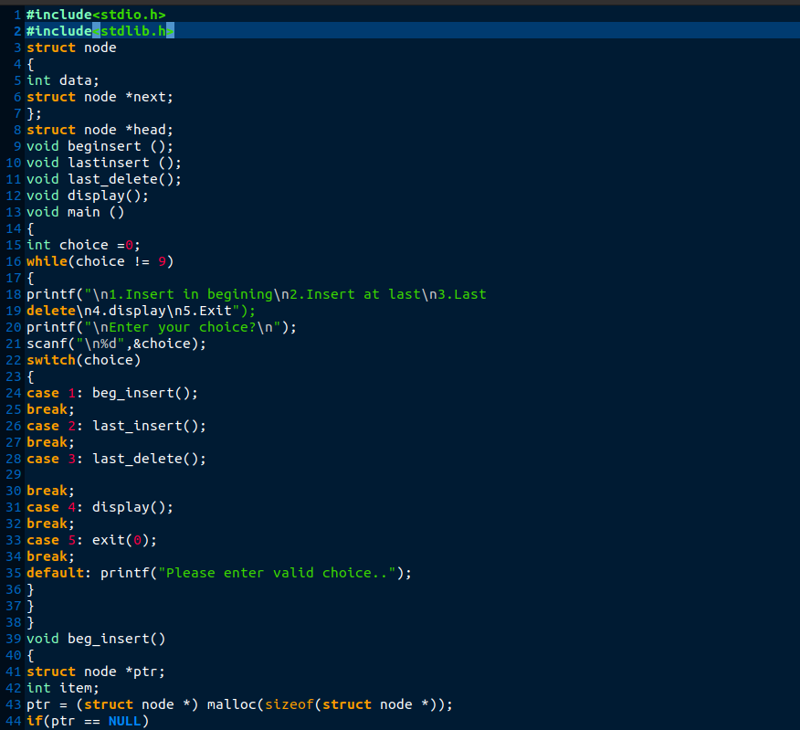

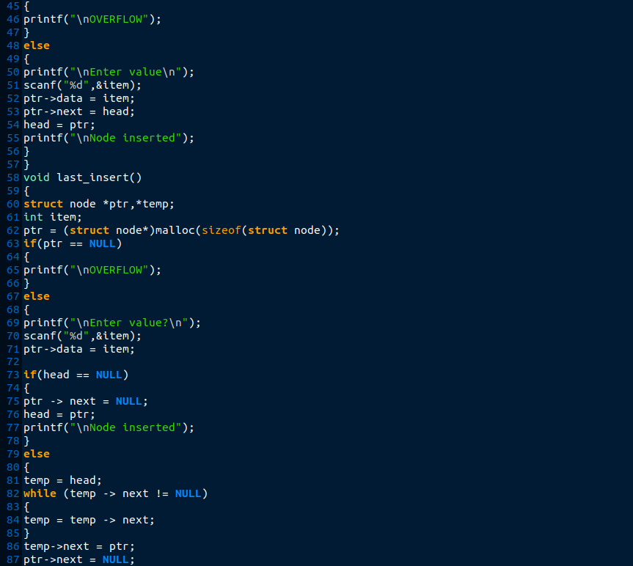

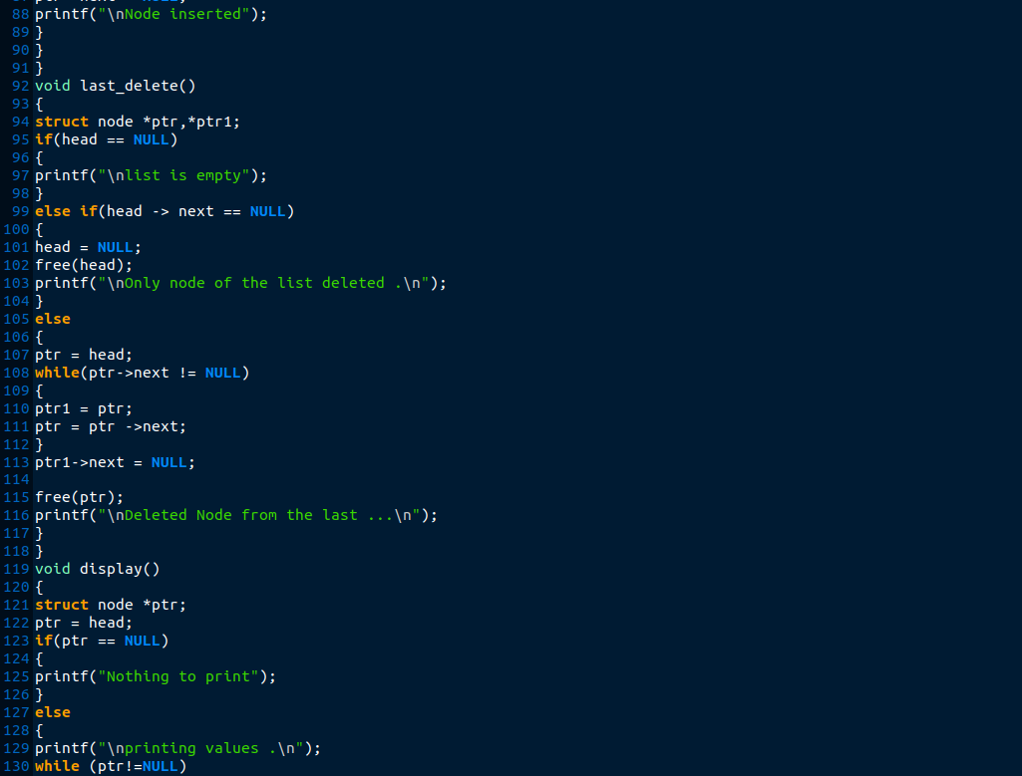

**Output:**

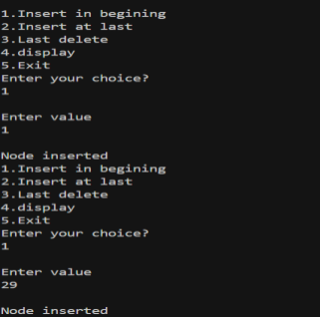

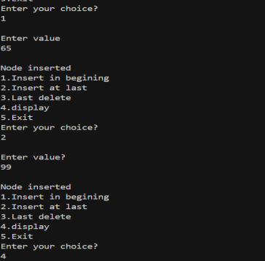

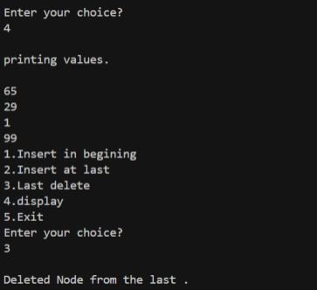

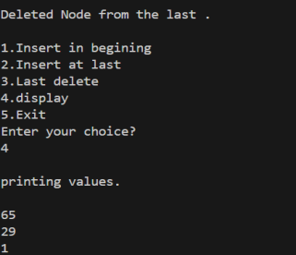

**Submitter Details:-**

**Name:** Abhinav.S.Dasari

**Roll No:** 16

**Div/Batch :** A/ S-2